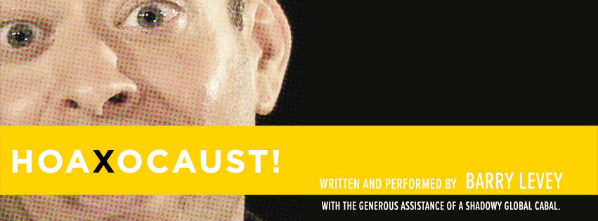
Performance fee: $1000* if within 30 miles of NYC
(schools outside of the radius will have additional travel expenses)
*Includes pre-show and post-show lesson plans
Barry Levey (writer, performer): New York productions include Woman of Troy (Upstart Creatures), Maimed (Project Y), Hoaxocaust! (Hoaxocaust! (Theater at the 14th Street Y, FringeNYC 2014 Overall Excellence Winner, Baruch Performing Arts Center, Theater for the New City, Prospect Theater Company); Critical Darling (The New Group); All the Way From China (Mad Dog at the Gene Frankel); and two shorts for Ars Nova, Downeaster Alexa and Yale Law School, the latter of which was a finalist for the Heideman Prize from the Actors Theatre of Louisville. Barry is a two-time O’Neill finalist whose work has been developed by Resonance Ensemble, the Lark, Arena Stage, Rattlestick, and Williamstown, among others. He holds a BA from Yale and an MFA from UC San Diego. Proud member, Dramatists Guild

ASSEMBLY FOR HIGH SCHOOLS:
INFORMATION LITERACY AND HOLOCAUST DENIAL
If the Holocaust didn’t happen… what do deniers want you to think?

“In Hoaxocaust—the award-winning one-man show that frolics as it gaslights everything we think we know about the Holocaust—its writer/performer Barry Levey, in a format comparable to a Ted Talk or an episode of Who is America,… interview(s) different Holocaust deniers throughout the world to get to the bottom of their theories and expose the dangers of what we all know as ‘fake news.’” ~Gregor Collins, Theater That Matters

Hoaxocaust! is a satire about Holocaust denial, and it provides an improbably entertaining Holocaust education opportunity that encourages students to think critically about “fake news”. Climate change denial, “birtherism,” and allegations that school violence is staged, are all referenced in the show. However, Hoaxocaust!’s truly universal theme is the significance of our various ethnic, cultural, or religious identities in a time of increased political tribalism. Most importantly, students (of history, government, citizenship, social studies, and more) will identify with the play’s funny, unreliable narrator and find the lesson engaging.

The show has performed for several student groups, including the Baruch College Campus High School, Williamsburg Charter High School, and groups from Global Kids, City Kids and the Lower East Side Girls Club. Attached is a fact sheet about Holocaust Denial that summarizes its presentation in the show. We would be happy to make this available to your school group along with pre-& post-show lesson plans, and hold a brief talkback with the students after the 75-minute performance to discuss their reactions.

www.hoaxocaust.com
Reference

My name is Jeremy Kronenberg and I am the Theatre Teacher and Department Leader for the Performing Arts department at Williamsburg Charter High School. I teach various styles and levels of theatre to students in 9th -12th grades with curriculum that is not only aligned to the NYS Standards for the Arts, NYC Blueprint and Common Core but is used as a catalyst for student driven work and discovery. The classroom-training centers on fostering students’ self-confidence and self-worth through the practice and application of theatre technique and uses that work as a catalyst for students to gain technical command, increase confidence and develop emotionally, physically, intellectually, imaginatively, and socially.

This past fall, I brought 40 of my students to a student matinee of Hoaxocaust! at the Theater at the 14th Street Y. The experience was tremendously eye opening to them for many reasons. The material is thoughtful and challenging and the resulting dialogues and discovery yielded immeasurable benefits. From a theatrical point of a view, my students have had limited exposure to one-person productions and for many of them, this was their first time seeing a single storyteller on stage. My students are constantly exploring how to employ physicalization and vocalization to create unique, grounded, robust and authentic characters on stage. Each and every student was deftly able to articulate how Barry manipulated these changes to bring 10 different characters to life. Additionally, they gained tremendous encouragement into the power a single performer has in captivating an audience and taking them on a complex and multifaceted journey. My students were engaged throughout the entire performance and enthralled with Barry’s ability to not only connect to the audience but seamlessly jump in and out of the myriad characters.

From a purely pedagogical point of view, Hoaxocaust! offers students an opportunity to think critically, engage in rigorous debate and connect this work to our every day experiences of the changing sense of truth and the veracity of facts. It’s examination of the Holocaust, the ensuing revisionist history and exploration of the current political climate makes it a show that would easily resonate for a world history or government class. Hoaxocaust! and the ensuing post-show dialogue aligns beautifully to ELA Common Core Standards by theatricalizing a topic that will undoubtedly “propel conversations by posing and responding to questions that probe reasoning and evidence; ensure a hearing for a full range of positions on a topic or issue; clarify, verify, or challenge ideas and conclusions; and promote divergent and creative perspectives.” (CCSS.ELA-LITERACY.SL.11-12.1.C)

There are so many opportunities to tie this play into the curriculum that is happening in your classroom and I would welcome any opportunity to speak more about its value for your students The play does contain mature themes, and provocative language. However, if you have any questions about the play, its educational content, or its suitability for high school students, please don’t hesitate to contact me for more information.

(after-show handout)
Hoaxocaust!

Hoaxocaust! is a work of fiction satirizing actual arguments from the literature and commentary of Arthur Butz, David Irving, Robert Faurisson, and The Protocols of the Elders of Zion. Characterization and dialogue have been invented. No assistance was provided by the Federation for Jewish Communities in Russia. Or a shadowy, global cabal.

Holocaust denial centers on three tenets: contesting the number of Jews killed, and thereby the extent of the tragedy; denying Hitler’s intent to systematically kill Jews, thereby voiding the claim of genocide; and disputing the use of gas chambers, thus reducing the extermination camps to internment centers.

The Numbers
“The simplest reason for being skeptical about the extermination claim: at the end of the war, they were still there.”
‐‐Arthur Butz, The Hoax of the 20th Century
Estimates of Jewish Holocaust victims vary today from 4.5 to over 6 million, a number continually revised by new research. 6 million was the figure first cited by Nazis at the Nuremberg trials. To corroborate it, scholars have consulted German camp censuses; SS kill reports; pre‐ and post‐war demographics (adjusted for those who emigrated, were liberated, or remained at liberty); and a 1943 report by an SS statistician, among other sources.

Hitler’s Intent
“No documentary evidence exists that Hitler was aware what was befalling the Jews.”
‐‐David Irving, Hitler’s War
Scholars debate Hitler’s initial objectives concerning Jews. Functionalists hold that he originally intended to transport Jews out of Europe, but turned to killing them when he literally ran out of space to hold them. Intentionalists believe Hitler planned their extermination from the start as a primary objective. Either way, Hitler authorized the genocide of Jews, proven by diary entries, Nuremberg testimony, the Wannsee Protocol, and his own public speeches.

The Gas Chambers
“According to photographs ‘retouched’ by the Allies, the roof of this gas chamber had four special openings through which Zyklon was poured in. But as anyone at the site can observe for himself, none of those four openings ever existed. No holes, no Holocaust.”
‐‐Robert Faurisson, “Impact and Future of Holocaust Revisionism”
Evidence that gas chambers were used for genocide include orders for Zyklon‐B; architectural blueprints; invoices for building materials; testimony from prisoners, guards and commanders; and photographs from within and above the compounds. A detailed engineering study of the gas chambers called Auschwitz: Technique and Operation of the Gas Chambers was published in 1989 by Jean‐Claude Pressac, a former protégée of Robert Faurisson whose research completely refutes the claims of his mentor.

Additional Resources
Cohn, Warrant For Genocide, 1996
Lipstadt, Denying the Holocaust, 1994
Shermer & Grobman, Denying History, 2000
http://holocaustcontroversies.blogspot.com/

For Information on Hoaxocaust! Written and performed by Barry Levey with the generous assistance of a shadowy global conspiracy, and Fox; please contact:
info@hoaxocaust.com
www.hoaxocaust.com
www.questingbeast.info

973-983-3266
www.americanedcon.com
americaneducationalconsultants@gmail.com

