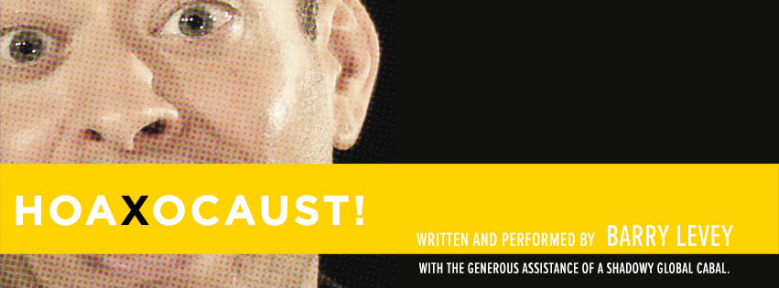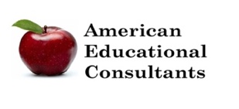

“In Hoaxocaust—the award-winning one-man show that frolics as it gaslights everything we think we know about the Holocaust—its writer/performer Barry Levey, in a format comparable to a Ted Talk or an episode of Who is America,… interview(s) different Holocaust deniers throughout the world to get to the bottom of their theories and expose the dangers of what we all know as ‘fake news.’” ~Gregor Collins, Theater That Matters

*Hoaxocaust!* is a satire about Holocaust denial that ran off-Broadway in 2018 and won the New York Fringe Festival’s Overall Excellence Award. It provides an improbably entertaining Holocaust education opportunity that also **encourages audiences to think critically about “fake news”** from climate change denial and “birtherism” to allegations that school violence is staged. However, *Hoaxocaust!*’s truly universal theme is the significance of our various ethnic, cultural, or religious identities in a time of increased political tribalism.  In the show, Barry travels the world questioning deniers, and engages the audience in a funny—and frightening—analysis of their views. Critics called the show “worthwhile and timely theater of the highest order” that “uses sharp satire to pierce the gasbags, finding laughs in a lot of strange places”.

**The performance lasts approximately 75 minutes with a 30 minute talk-back**

**following the show. Longer talk-backs can be arranged.**

**Performance Fee: $2,500 plus expenses**

More show information and reviews of the show can be found at [www.hoaxocaust.com](http://www.hoaxocaust.com)

To book or discuss particulars of hosting a performance, please contact American Educational Consultants

**973-983-3266** [**http://www.americanedcon.com/**](http://www.americanedcon.com/)[**americaneducationalconsultants@gmail.com**](mailto:americaneducationalconsultants@gmail.com)

**Barry Levey** (writer, performer): New York productions include *Woman of Troy* (Upstart Creatures), *Maimed* (Project Y), *Hoaxocaust!* (Theater at the 14th Street Y, FringeNYC 2014 Overall Excellence Winner, Baruch Performing Arts Center, Theater for the New City, Prospect Theater Company); *Critical Darling* (The New Group); *All the Way From China* (Mad Dog at the Gene Frankel); and two shorts for Ars Nova, *Downeaster Alexa* and *Yale Law School*, the latter of which was a finalist for the Heideman Prize from the Actors Theatre of Louisville. Barry is a two-time O’Neill finalist whose work has been developed by Resonance Ensemble, the Lark, Arena Stage, Rattlestick, and Williamstown, among others. He holds a BA from Yale and an MFA from UC San Diego. Proud member, Dramatists Guild

**If the Holocaust didn’t happen… what do deniers want you to think did??**